Step to Run the Program

1. Unzip apache-tomcat-8.5.0-windows-x64.zip
2. Put searchEngine.war in the newly extracted tomcat directory in following path:  
   tomcat directory/webapps/ searchEngine.war
3. Run startup.bat which is in following path  
   tomcat directory/bin/ startup.bat  
     
   Below window will be seen

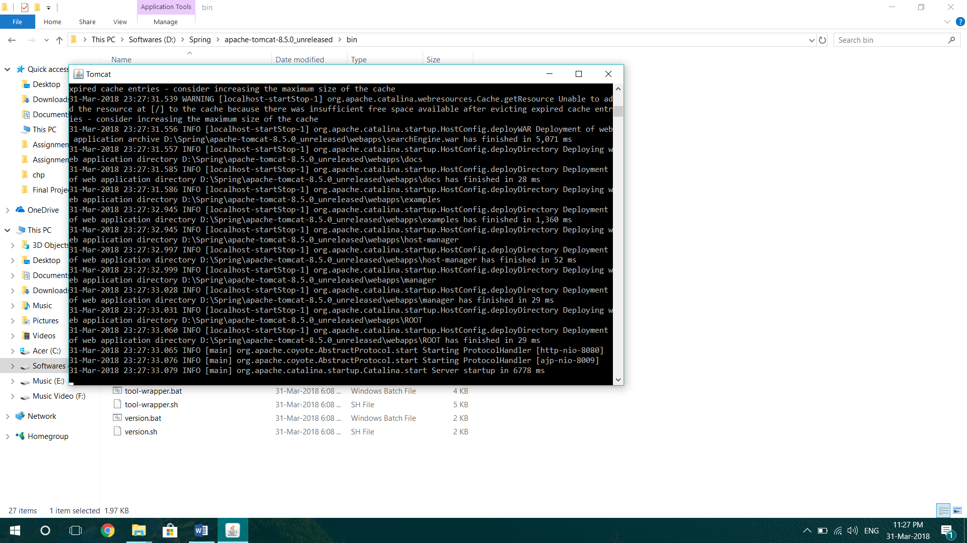

1. Open any browser and type below url  
   http://localhost:8080/searchEngine/  
   Below screen can be seen  
   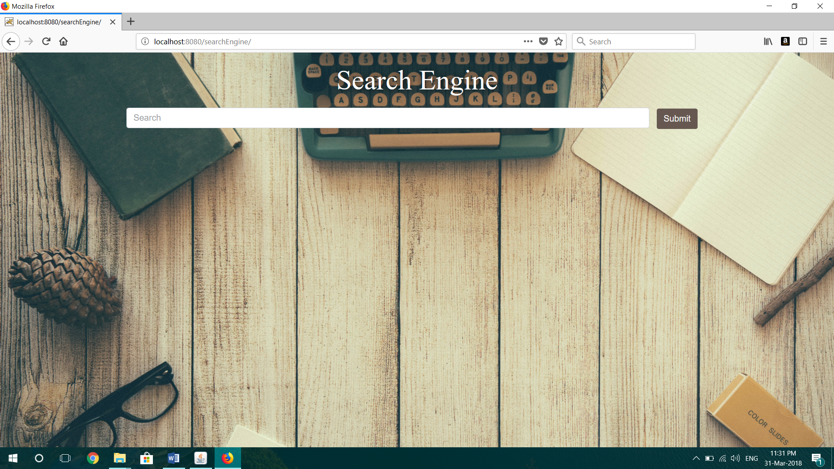
2. Type any word and you will see word suggestion to select from. Used edit distance algorithm  
   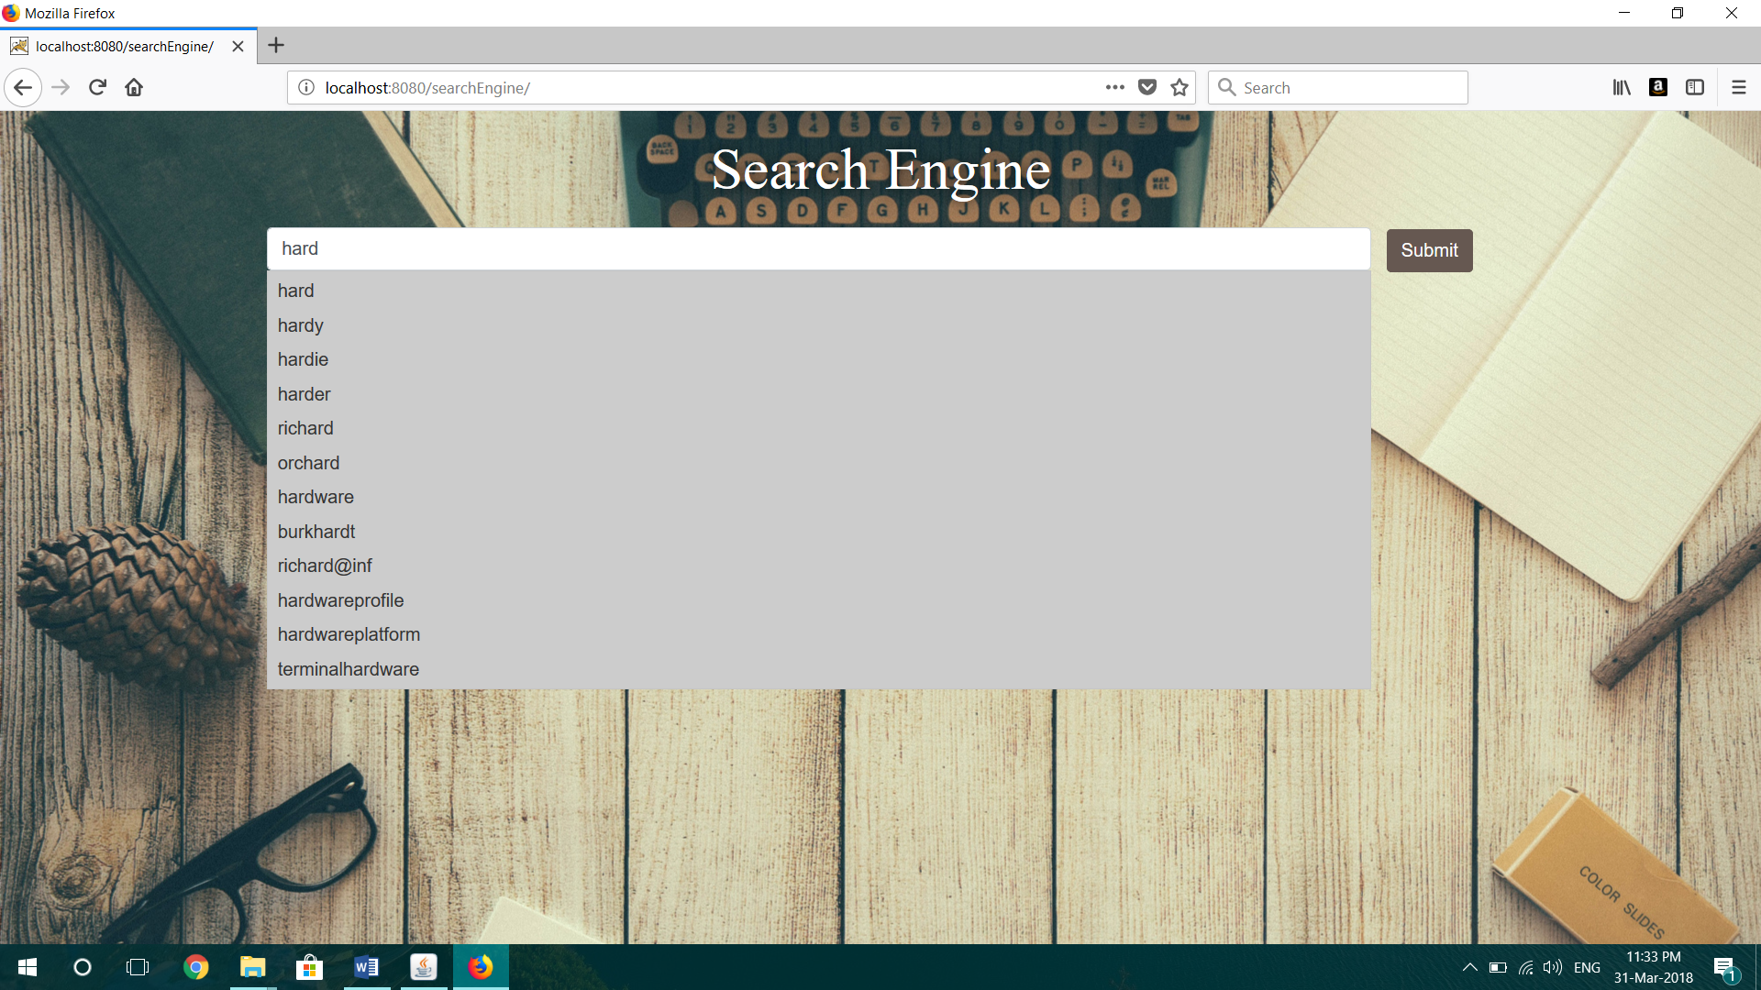
3. Click on submit and below screen will be seen. Page ranking as per frequency.  
   